

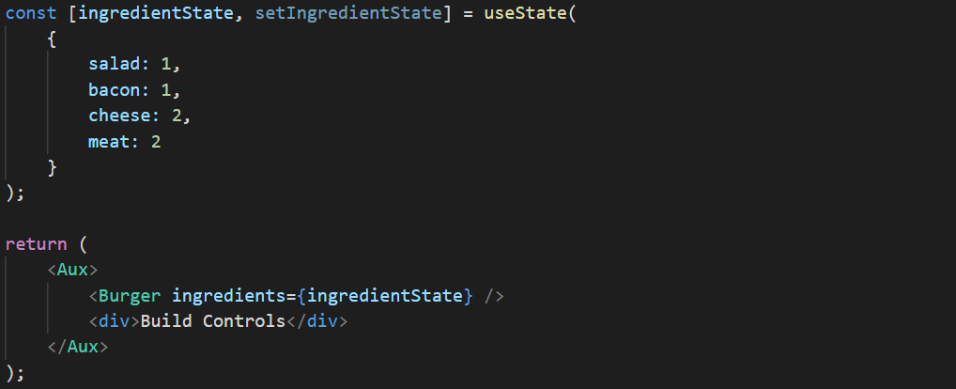





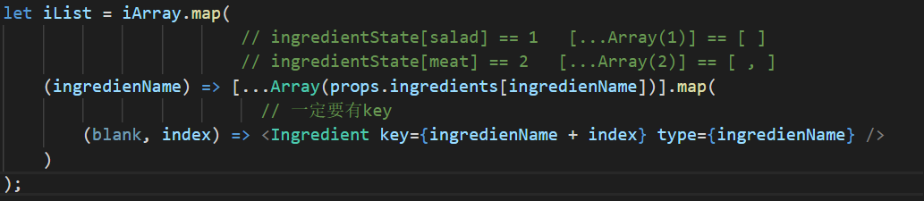

ingredientState == {salad: 1, bacon: 1, cheese: 2, meat: 2}

此時 iList如下



